All results for non-augmented data

Table 1 hyperparameter optimization

|  |  |
| --- | --- |
| **Hyperparameter** | **Value** |
| Batch size | 32 |
| Number of epochs | 30 |
| Steps per epochs | 51 |
| Loss function | Categorical crossentropy |
| Optimizer | Adam |
| Learning Rate | 0.01 |
| Dropout rate | 0.4 |
| Train test split ratio | 80:20 |
| Activation function | Relu, Softmax |
| Dense layer units | 1024 |

Table 2 model properties

|  |  |  |  |  |  |  |
| --- | --- | --- | --- | --- | --- | --- |
| Network Size | Year | Size(mb) | Depth | Learning Rate | Total parameters | Accuracy (%) |
| VGG16 | 2014 | 129 | 23 | 0.001 | 21,139,014 | 96.54 |
| DenseNet121 | 2018 | 40 | 121 | 0.01 | 8,093,254 | 96.13 |
| NASNetMobile | 2018 | 30.8 | - | 0.01 | 5,358,234 | 94.51 |
| MobileNet_V2 | 2017 | 24.1 | 88 | 0.01 | 3,575,878 | 92.88 |
| ResNet50_V2 | 2016 | 384 | 50 | 0.01 | 126,332,422 | 92.27 |
| Inception_V3 | 2015 | 233 | 159 | 0.001 | 21,802,784 | 91.26 |

GRAPHS:

test accuracy for class 1: 0.9979674796747967

test precision for class 1: 0.9879518072289156

test recall for class 1: 1.0

test f1 score for class 1: 0.993939393939394

test accuracy for class 2: 0.9878048780487805

test precision for class 2: 0.9318181818181818

test recall for class 2: 1.0

test f1 score for class 2: 0.9647058823529412

test accuracy for class 3: 0.9654471544715447

test precision for class 3: 0.9850746268656716

test recall for class 3: 0.8048780487804879

test f1 score for class 3: 0.8859060402684563

test accuracy for class 4: 0.9654471544715447

test precision for class 4: 0.8494623655913979

test recall for class 4: 0.9634146341463414

test f1 score for class 4: 0.9028571428571428

test accuracy for class 5: 1.0

test precision for class 5: 1.0

test recall for class 5: 1.0

test f1 score for class 5: 1.0

test accuracy for class 6: 0.9939024390243902

test precision for class 6: 1.0

test recall for class 6: 0.9634146341463414

test f1 score for class 6: 0.9813664596273292

FOR vgg-16

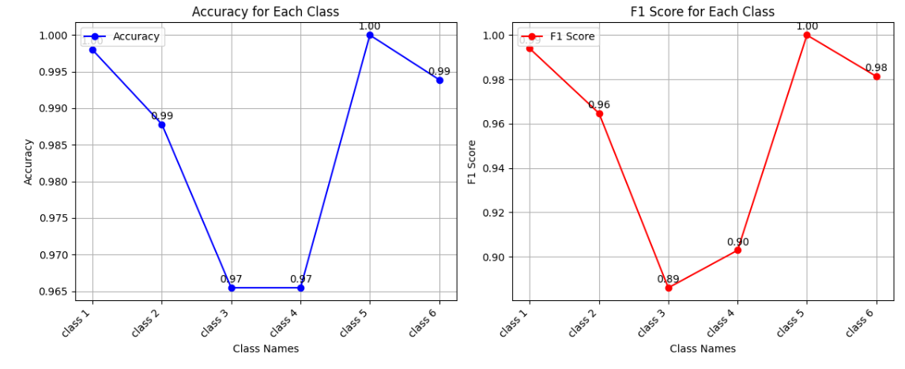

resnet_50:

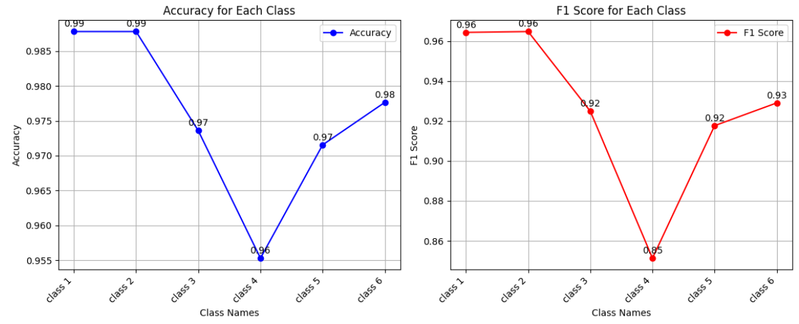

Inception:

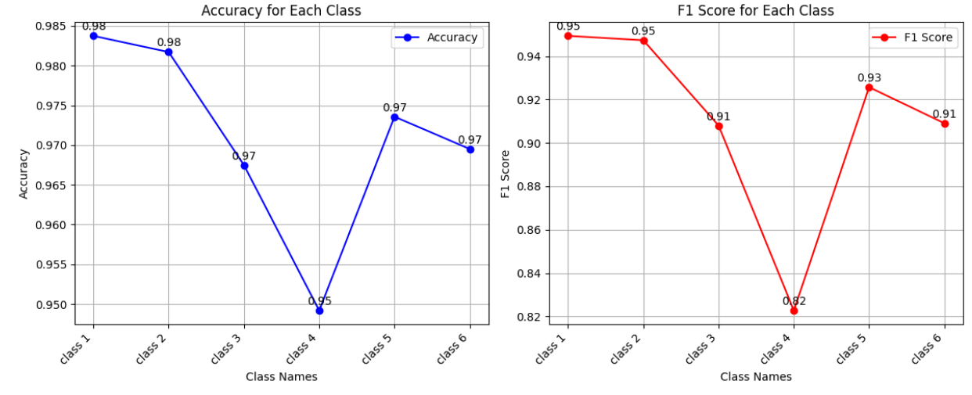

Mobile_net:

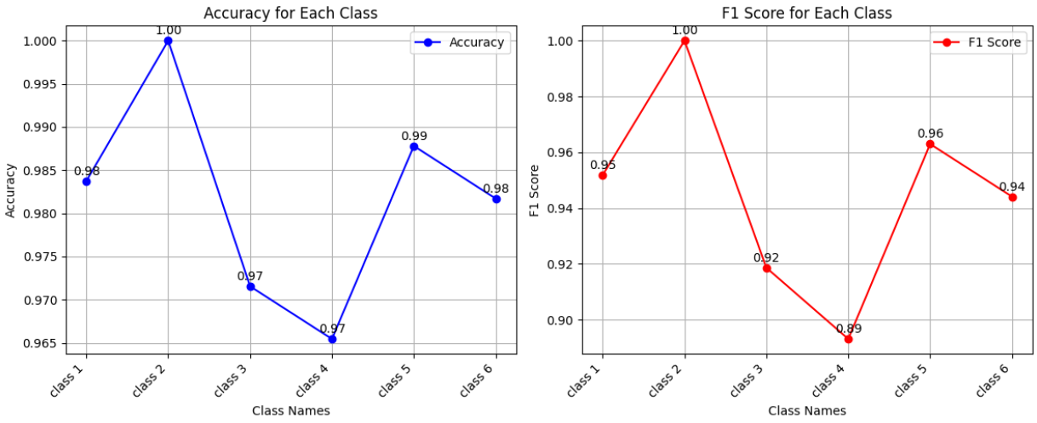

Dense net:

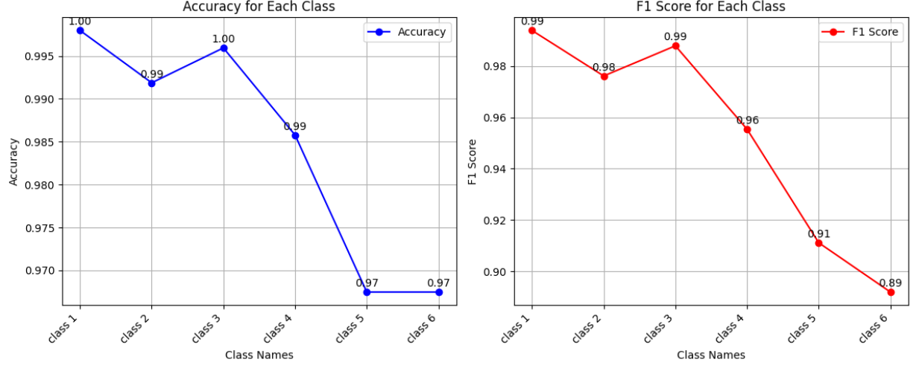

Nasnet:

––––––